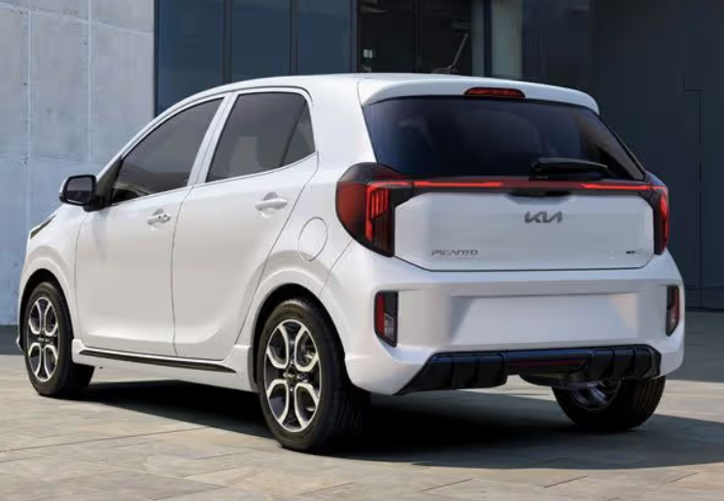

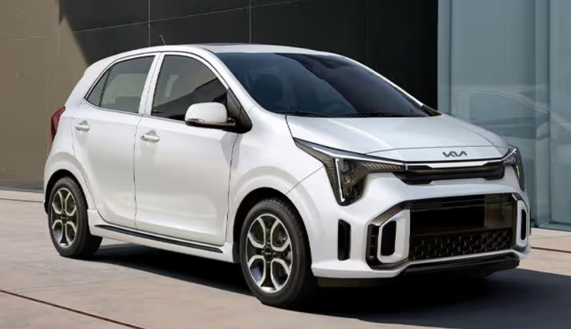

**Main specifications** of the **2025 Kia Picanto**:

**🔧 Powertrain & Performance**

* **Engine**: 1.2 L inline-4 MPI petrol, ~84 hp (62 kW) and 122 Nm torque, paired with either a 5-speed manual or 4-speed automatic transmission
* **Drivetrain**: Front-wheel drive
* **0–100 km/h**: Approximately 12–13 seconds (auto/manual)

**⛽ Fuel Economy & Emissions**

* Combined fuel consumption: ~5.4 L/100 km (manual) and ~6.0 L/100 km (auto) (~46–52 mpg UK)
* CO₂ emissions: Around 118–125 g/km

**📏 Dimensions & Weight**

* **Length**: 3,595 mm
* **Width**: 1,595 mm
* **Height**: 1,485–1,495 mm
* **Wheelbase**: 2,400 mm
* **Ground clearance**: ~141–152 mm
* **Boot space**: 200 L (basic) up to 255 L with seats up
* **Curb weight**: ~840–990 kg depending on trim

**🛋 Interior & Technology**

* Seats 5 passengers in a 5-door hatchback layout
* 8" touchscreen infotainment with Apple CarPlay & Android Auto; 4.2" digital instrument cluster
* Standard comfort features: manual air-con, power windows, keyless entry (select trims), rear USB-C

**🛡 Safety & Driver‑Assist**

* Standard safety: ABS, ESC, dual front airbags, optional side/curtain airbags (up to 6), rear camera and sensors
* ADAS options include autonomous emergency braking, blind‑spot assist, lane‑keep assist, lane-centering, rear-cross traffic alert, rear occupant alert

**🏁 Chassis & Handling**

* Platform: Kia's “Opposites United” facelifted design, Heartect-based
* Suspension: Front MacPherson strut, rear torsion beam
* Wheels: 14″ standard; crews may include 15–16″ alloys on higher trims

**✅ Quick Summary Table**

| **Feature** | **Spec** |
| --- | --- |
| **Engine** | 1.2 L I4, ~84 hp, 122 Nm torque |
| **Transmission** | 5MT / 4AT |
| **Drive** | FWD |
| **0–100 km/h** | ~12–13 s |
| **Fuel Efficiency** | ~5.4 L/100 km (manual) |
| **Dimensions (L×W×H)** | 3,595×1,595×1,485‒1,495 mm |
| **Wheelbase** | 2,400 mm |
| **Boot Space** | 200–255 L |
| **Infotainment** | 8″ touch + CarPlay/Android Auto |
| **Safety Features** | AEB, BSM, LKA, up to 6 airbags |
| **Warranty** | Typically 7‑year Kia warranty in many markets |